DESIGN DOCUMENT/USER GUIDE

The Library management system is designed to perform the following operations

1. Book Search and availability
2. Check-in of books
3. Check-out of books
4. Addition of new Borrowers
5. Fines information
6. **Design decisions-**
7. GUI Design

The user interface is built using Java- swing technology for front-end design. The 5 functionalities are implemented using 5 different J-tabs .

1. Backend design

The back end is implemented using java-JDBC technology and it is connected to a mySQL database.

Imported referenced libraries- connector-java-5.1.38-bin.jar ; jgoodies.jar

1. **Design timeline,Functionality ,Testing and Assumptions**
2. Book search and availability-

The Book search is done with input as Isbn, title and author name. None of the fields are mandatary. On the submit button click, first, the available copies are calculated for all the similar fields which match to the input. Then, the resultant table is joined to the authors and Library-branch fields to generate the required table formatted output. Assumption is that the inputs are valid and atleast one entry which corresponds to the input exists. Below is the screenshot of the book_search;

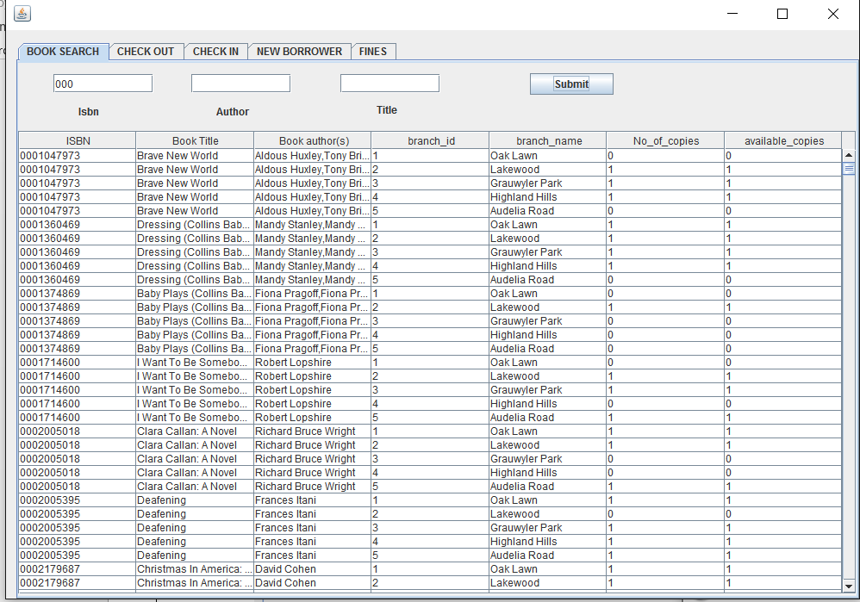

1. Check out of books-

The check_out button ensures the checking out of books. The inputs must be valid and the book_id must exist in the database for the check_out to happen. Assumption is that the inputs are valid and atleast one entry which corresponds to the input exists.

Assumptions

* All fields are mandatary.
* Borrower card number must be an integer and not a string or alphanumeric

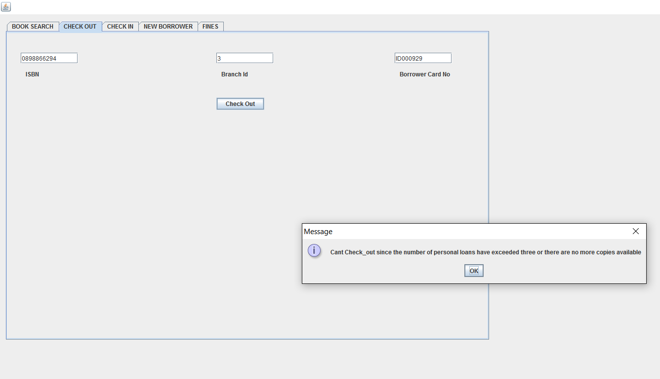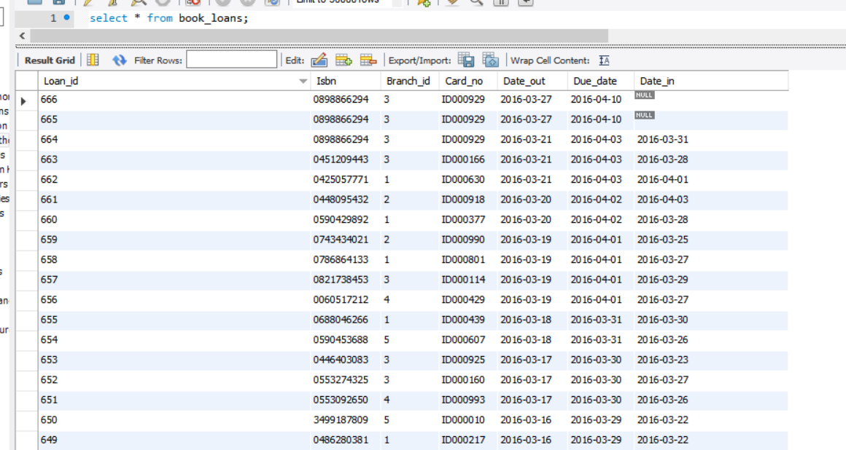

the above pictures show tuples with Loan_id-665,666 being added for Isbn=0898866294. When the user limit exceeds or when no more copies of books are available, it throws an exception to user with a meaningful message.

1. Check-in

Check in is done after first selecting a book to be checked in from a book search . Once, a book is checked in , its due date is changed to current

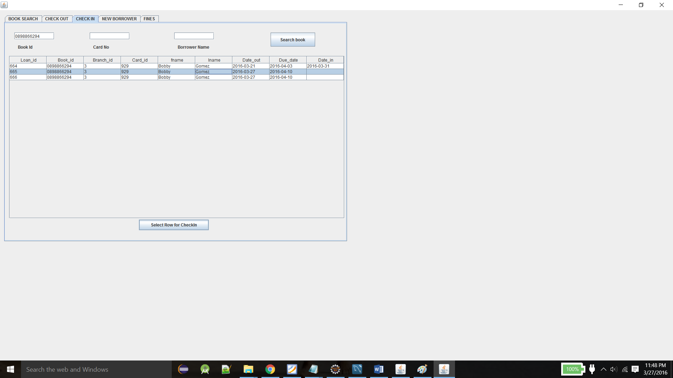

1. Add Borrower

A shown in the picture below, the fields which are mandatary must be filled. And then the add borrower button ensures addition of a borrower.

Assumption , all fields indicated mandatary must be entered.

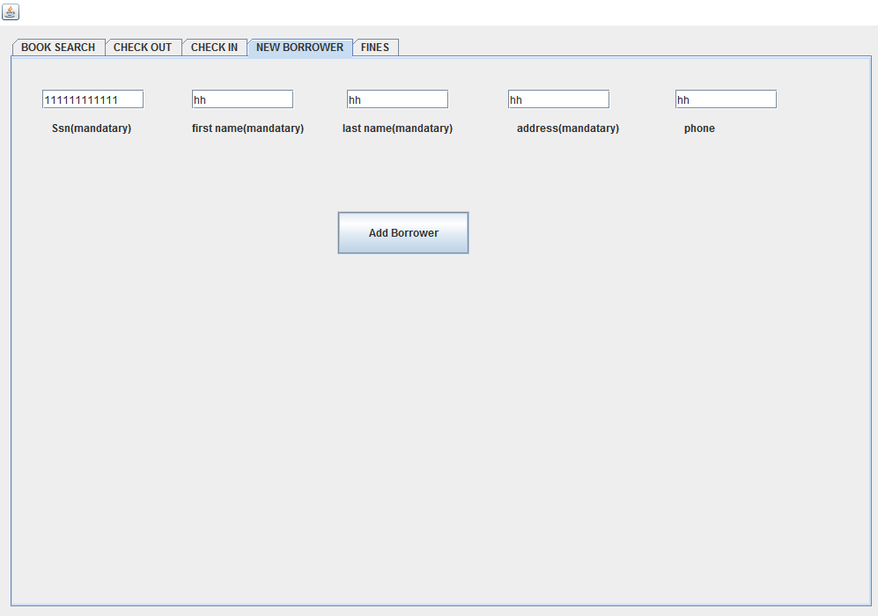

1. FINES

Fines are refreshed automatically. There is also an option to display only the current pending fines. Librarian can also physically update a fine given a loan_id and fine amount. Loan_id must be valid and must exist.

Assumptions-

* Fine_amount and loan_id must be numeric
* Update fine only updates fine when book is checked in. For other purposes, the refresh button takes care of it .

